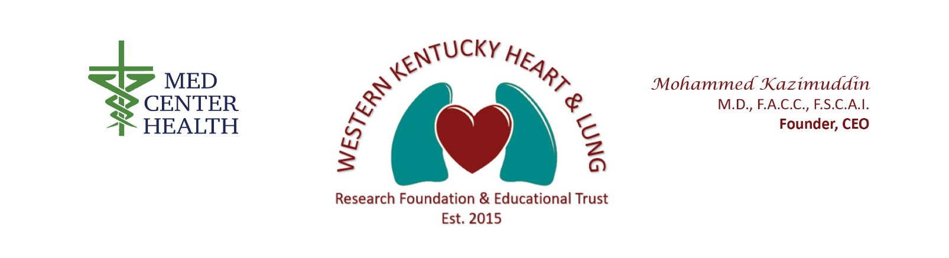

Purpose:
The purpose of the Research Foundation is to promote robust research projects conducted by the medical residents, Fellows, healthcare students, Med Center Health employees, or medical staff in a collaborative manner between Western Kentucky Heart and Lung Research Foundation and Educational Trust and Med Center Health. The research should be meaningful for the health-system and the community with the expectation that it will be published and/or presented at a medical conference or symposia.

Role of the Research Foundation:
The Research Foundation (Foundation), a multidisciplinary group of physicians and other healthcare providers will meet with the medical students, residents, and fellows on a monthly basis. The Foundation members will listen to the resident/ fellow/ student discuss the research proposal and provide constructive feedback to the resident/ fellow/ student and may serve as a mentor for the project. Any other individual, such as a physician or other Med Center Health employee wishing to pursue a research project involving Med Center Health should also present before the Foundation. All research projects will receive final, written approval from Dr. Mohammed Kazimuddin, Foundation President, and Drs. Aniruddha Singh and Melinda Joyce, Co-Chairs.
The following information should be part of the initial presentation of a research proposal:
- New Research Project Idea Requirements
  - Is there a defined objective?
  - What is the rough study design?
  - What literature review has been done for this research project?
  - How will the research benefit the health-system and/or the community?
  - Will the research require IRB approval?
  - Will an informed consent be needed for the research project? If so, does the informed consent contain all the required elements?
  - Will a statistician be required for the project?
  - What is the anticipated budget?
  - What is the anticipated timeline for this project?
  - Are there potential concerns/ barriers to the completion of this project?
  - Where will this research most likely be published?
  - At which conference(s) or symposium(s) will this research most likely be presented?
  - Is a Mentor/Advisor needed for this project? If yes, has a Mentor/Advisor identified?
The Foundation members will also receive regular updates from the residents/ fellows/ students regarding the ongoing research projects and provide constructive feedback. The following information should be part of the presentation for on-going research projects.
- On-Going Research Project Requirements
- The Researcher will present regular updates via Project Reports to the Foundation’s Research Advisor Group, including slides.
- Is the research following the established study design?
- Have any concerns/ barriers been identified with the research?
- Will the research be completed within the projected time line? What obstacles or barriers may intervene?

Research Foundation Membership:
The members of the Research Foundation should have:
  - A strong interest and commitment to research and to mentorship.
  - A collegial working relationship with the residents/fellows/ students.
  - Time availability for a monthly meeting on the third Thursday of each month at noon with a minimum of 50% attendance at the meetings.
  - The terms of the Research Foundation will be 2-year terms.

Research Project Process
- Identification of a research project through collaboration with attending physician, mentor, or colleagues.

- Completion of a Research Project Proposal form, which is available on-line at wkhlresearch.com/research-project-proposal. You will receive confirmation upon the Foundation’s receipt of your proposal.

- Dr. Joyce and Dr. Singh will review the project form and determine if additional assistance from WKU or others may be beneficial, such as a complete study design review or statistician help. If additional assistance for the project is required, Dr. Joyce and Dr. Singh will handle the logistics of arranging the additional assistance based on the need. The investigator will be notified as to who to contact at WKU. It will then be the responsibility of the investigator to set up a meeting to discuss pertinent issues of the research project.

- Please do not reach out to the WKU faculty for help with a research project without contacting Drs. Joyce and/or Singh first. Drs. Joyce and Singh are here to help streamline and facilitate the process.

- If it is determined that no additional assistance will be required, the investigator will be asked to present their research project idea at the next upcoming Research Foundation meeting.

- If updates/changes to the proposal are requested, those changes must be made before proceeding with the research.

- The following elements are required for the Project Proposal form and should be included in the project presentation:

  - Defined objective with hypothesis
  - Rough study design
  - Results of a literature review
  - Benefit of the research project to the health-system and/or community
  - Whether or not IRB approval will be needed
  - Whether or not an informed consent will be needed
  - Proposed budget
  - Methodology
  - Timeline
  - Potential barriers/ issues for the completion of the project
  - Where will he research most likely be published or what conference will the project be presented
  - Mentor

- It is necessary for one of the first slides of your presentation to outline the hypothesis of the study along with a brief rationale for the project. That will help set the stage for the participants to know the type of study along with the scope.
- It is also important to be prepared and to keep the length of your presentation to no more than 5 -7 minutes so that there can be time for discussion. You will have a total of 15 minutes for the presentation and discussion.
- Please be sure to define any abbreviations or acronyms at least once in the presentation.

- Once the project has been presented, it will then be a documented on-going project, subject to periodic updates to the Research Foundation.

- Any Investigator(s) who believe their project is complete and ready to be published or presented at a conference or symposium should submit their project for final approval by the Project Approval Subcommittee. Prior to submitting for final approval, seek approval from all members of the research project, including attending physicians when applicable.

- Complete the Final Project Submission form posted on wkhlresearch.com/finalsubmission; any updates to this form are effective upon posting to wkhlresearch.com.

- Once a Final Project Submission form is received for your project, you will be contacted to set up a presentation at one of the monthly foundation meetings. All projects must be presented to the Project Approval Subcommittee consisting of the Foundation President- Dr. Mohammed Kazimuddin, Chair- Dr. Aniruddha Singh, and Co-Chair- Dr. Melinda Joyce.

- Once presented, you will either receive an approval form, or a request for changes or improvements to be made. The approval form serves as written documentation that the research is ready to be published or presented in a public setting. If a request for changes is made, those changes must be within a timeframe designated by the Project Approval Subcommittee.

Projects may not be presented or published in a public forum until the above process is completed and final approval is awarded.

- The Foundation must be notified of all publications and/or presentations of Research completed in conjunction with the Foundation. This must be done through the form found at wkhlresearch.com/publication-presentation-notice.

For more information, please contact Sheryl Morris [smorris@wkheartandlung.com].

